**Calculating population-wide spatial and seasonal relative abundance indices for Atlantic bluefin tuna for use in operational modelling**

Tom Carruthers[1]

*SUMMARY*

Nominal catch rate data from multiple fleets were combined to derive relative abundance indices for the temporal and spatial strata of bluefin tuna operating models. These indices allow for the calculation of standardized effort in any strata where a fleet reports catches. Standardized effort allow operating models to be conditioned more rapidly and robustly.

*KEYWORDS*

*Population modelling, fishery statistics*

# Introduction

A common approach to modelling fishing mortality rates in fisheries stock assessment models is to estimate a fishing mortality rate parameter for each strata (*e.g*. a year and a fishing fleet) for which there are observed catches. In a typical stock assessment model for a tuna species (*e.g.* Pacific bluefin tuna, ISC 2016) this could be 10 fleets and 40 years (a total of 400 fishing mortality rate parameters) which is tractable in conventional estimation software such as AD Model Builder (Fournier et al. 2012) and Template Model Builder (Kristensen et al. 2016). However in the case of the operating models for Atlantic bluefin tuna, the number of strata is substantially higher due to the requirement of spatial and seasonal dimensions to account for mixing of Eastern and Western stocks. In the most recent operating model specification this includes over 55 years, 13 fleets, 10 areas and 4 quarters (*e.g*. January-March, April-June, *etc*) requiring a total of 28,600 fishing mortality rate parameters assuming catch observations in every strata and still around 10,000 parameters given 1/3 coverage. Since these numerous parameters can also be expected to be correlated in many instances (*e.g*. high estimated exploitation rates in one time-period reduce biomass and hence inform higher exploitation rates in subsequent time-periods) this constitutes a challenging estimation problem even for the most efficient contemporary software.

An alternative modelling approach is to condition the stock assessment model on effort data, *E*. In this configuration, fishing mortality rates *F*, are estimated by assuming that fishing mortality rate is proportional to effort via the equation *F*=*qE* where *q* is the catchability of the fleet. This is analogous to assuming catch divided by effort (*C*/*E* or CPUE) is proportional to abundance, a common assumption in the assessment of tuna and billfish species: *C*/*A* = *qE*, *C*/*E* =*qA*. The effort data used in this example should be standardized for the same reason that CPUE data are standardized: to better preserve the relationship between effort and exploitation rate by accounting for confounding factors such as units of measurement, species targeting, gear configuration, location, season and year.

This alternative ‘conditioned on effort’ assessment approach has the core advantage that only a single catchability parameter *q*, is estimated per fleet. In the example of Atlantic bluefin tuna operating models above, this requires the estimation of just 13 parameters instead of many thousands. There are however two important limitations of the approach. (1) Catch and effort can only be used once and therefore the model is fitted to just observed catches; given the rearrangement of equations above it would be reusing data to include CPUE indices derived from the same effort data used to predict the same catch observations. (2) The standardized effort data required by this modelling approach are not available for the fleets of the current bluefin tuna operating model (Table 1).

To enable Atlantic bluefin tuna operating models to be conditioned on effort, I investigate the derivation of a combined ‘master index’ that represents bluefin tuna vulnerable biomass over all time and area strata (*i.e.* an index data point for the 55 years, 4 quarters and 10 areas of the model). If such a master index can be calculated, a standardized effort datum can be calculated by dividing the observed catches of any fleet by the master index *I*, *i.e*: $E=C/{qA∝C/I}$. This approach has the merit that even if a fleet reports effort in many different units or does not report covariate effort at the appropriate spatio-temporal resolution, as long as catches are reported a standardized effort can be calculated. It follows that rapid changes in fleet definitions are possible that do not require the recalculation of standardized indices for each fleet which are typically carried out on confidential trip-level data by government scientists.

# Methods

## A generalized linear model

It has been become common practice to conduct CPUE standardization by considering multiple linear models and using model selection criteria to pick the most parsimonious model from a large set. There are a number of potential problems with this approach:

1. statistical model selection criteria such as AIC generally aim to identify a model that parsimoniously predicts the next CPUE observation and are inconsiderate of the principal objective of CPUE standardization: to extract a reliable marginal year effect;
2. in most CPUE standardizations the statistical assumptions of model selection are invalid particularly the assumption of non-independence in observations of catch per unit effort;
3. model selection criteria such as AIC require the assumption that one of the candidate models is a close approximation to the model generating the data, which is quite unlikely given that few standardizations account for prevailing fishery characteristics such as changes in fishing efficiency, shifts in species targeting *etc*;
4. there are typically much narrower set of models that meet simple logical requirements for approximating trends in relative abundance and fishery dynamics.

In this application, the absence of detailed trip-level data provides little scope for elaborate investigation of covariates of CPUE such as gear configuration, vessel specific catchability and continuous spatial-temporal models (*e.g*. splines, GAMs etc). The CPUE considered in this analysis are the nominal Task II catch and effort data reported to ICCAT and published online (ICCAT 2016). A total of 9 fleets are considered that may have CPUE that can be expected to inform relative density of fish (e.g. non purse seine gears). These fleets are described in Table 2. It follows that the potential limitations of model selection in points 1-3 above do not apply here. In this analysis I derive a master index based on the most complex model that can be fitted to data that also meets the logical requirements of a multi-stock, mixing model for bluefin tuna:

* there must be year – area interactions allowing for differing temporal trends among areas to account for multiple stocks (*e.g*. a declining CPUE in the Gulf of Mexico and increasing trend in Mediterranean or vice versa);
* there must be season – area interactions to account for seasonal migrations of fish;
* it is desirable to include fleet – area interactions to account for variable seasonal fishing behaviour (e.g. targeting).

To reflect these requirements the preliminary master index was constructed based on the linear model:

$\log\left({CPUE}_{y,r,m,f}\right)=α_{y,r}+β_{m,r}+δ_{f,r}+ε$ (1)

where the subscripts *y*, *r*, *m* and *f* refer to years, areas, seasons and fleets, respectively. The *α* terms are year – area interactions, *β* terms are season (quarter) – area interactions, *δ* terms are fleet-area interactions. Expansion to more complex interactions (*e.g*. year – season – fleet) led to spurious model predictions of relative abundance among areas, seasons and years. It follows that given that trip level data are not available, this constitutes both the most and least complex model that is available for constructing the master index. There is however scope for producing alternative indices by including varying combinations of fleets (alternative index 1) and possibly by assuming constant catchability among areas (dropping the fleet-region interaction in favour of a simpler marginal fleet effect: alternative index 2).

A more thorough iteration of this modelling based on, for example, fine-scale trip data could consider a much more detailed account of the interaction of the fishery and population density. For example by accounting for density at finer spatial scales and a range of fishery characteristic such as gear configuration:

$\log\left({CPUE}_{y,R,m,f,g}\right)=α_{y,r}+A_{R}+β_{m,r}+δ_{f,r}+d_{f,g}+ε$ (2)

where the *d* terms account for fleet specific gear g, configurations that may affect catchability. The A terms are marginal effects to account for density estimates over finer spatial strata *R*, such as 5 x 5 or 1 x 1 degree spatial grid. If these fine-scale spatial phenomenon are assumed to be year- and season-specific they could be predicted as a function of habitat data *H*, such as sea temperature data:

$\log\left({CPUE}_{y,R,m,f,g}\right)=α_{y,r}+f\left(H_{R}\right)+β_{m,r}+δ_{f,r}+d_{f,g}+ε$ (3)

More detailed analysis of trip-level data should consider both positive CPUE and the frequency of zero CPUE observations (*i.e*. a delta-lognormal mixture model, Maunder and Punt 2004.). Mixture models can account for increasing sparsity of positive observations, e.g:

$\operatorname{logit}\left(∆_{y,r,m,f}\right)=α_{y,r}+β_{m,r}+δ_{f,r}+ε$ (4)

Where the *Δ* is the fraction of positive catch rate observations. Mixture models of CPUE data have a potentially serious flaw in that they can lead to biased relative abundance indices if fishing practices have become increasingly intelligent over time or are less likely to observe zero catch rates as stocks decline (*i.e*. use of GPS, data sharing, increasingly sophisticated fish finders to maintain economic viability). These phenomena are prevalent in pelagic fisheries targeting billfish and tuna and so mixture models should be considered with some caution (it is possible that the positive CPUE data alone, contain the most reliable relative abundance signature).

## Predicting population density and missing data

For straightforward prediction of relative abundance in each year, season and area, the linear model of Eqn 1 requires complete CPUE observations for every strata of each interaction effect, *i.e*. every combination of year - area (*α*) and season – area (*β*). However data for at least one fleet are not available across all of these strata (Table 1). The majority of bluefin catch observations (~85% by weight) occur where these CPUE data are present to inform the master index. However in the remaining cases the calculation of standardized effort requires the use of an index calculated outside of the range of CPUE observations. In these instances the index is imputed from the inferred marginal year, area and season effects calculated across the interactions calculated from data that are present. Density estimates were calculated using the R function ‘predict.glm()’ of the ‘stats’ package.

## Calculating abundance from predictions of population density

Atlantic bluefin operating models require abundance estimates at the coarse 10-area spatial resolution of Figure 1. The linear model predicts CPUE density at this resolution (Figure 3) which must be converted to abundance estimates using covariate data regarding the spatial area over which these observations are made. Seasonal coverage of CPUE observations at the resolution of 1 x 1 degree ocean cells was used to calculate the seasonal size *S*, of each of the 10 areas of Figure 1 (Table 2). This coverage was calculated for season – area cells for which at least one tonne of bluefin was caught historically. The densities predicted by the linear model *D* were then converted to initial abundance estimates by multiplication by the relative seasonal size of each area:

$A_{y,m,r}=D_{y,m,r}∙S_{m,r}$ (5)

The abundance predictions arising from this equation can exhibit high inter-annual variability among years (Figure 4). In some cases the extent of these fluctuations is not credible given a stock with the longevity of Atlantic bluefin tuna subject to relatively consistent fishery exploitation rates (*e.g*. Mediterranean in quarters 2-4, Figure 4). In a typical stock assessment framework, error in a relative abundance index is accounted for in the corresponding likelihood function. However in bluefin operating models the master index is proposed as a basis for calculating standardized effort for multiple fleets. It follows that an erroneous and overly low estimate of relative abundance will create a commensurately inflated prediction of standardized effort for all fleets in the model and hence the same number of inflated catch observations. Rather than use an index with unrealistically high inter-annual variability, a simple smoother (a cubic spline smoother, ‘smooth.spline ()’ of the R ‘stats’ package) was applied to create greater temporal consistency in the index among years whilst preserving the general temporal trends (Figure 5).

## Alternative scenarios for master index calculation

Two alternative indices were generated to characterize some of the uncertainty in the data and modelling.

The first index included CPUE data from two additional eastern fleets, the Spanish longline and Spanish bait boat fleets (Table 2).

The second alternative index used the same data as the master index but modelled CPUE with a marginal fleet effect rather than a fleet-area interaction:

$\log\left({CPUE}_{y,r,m,f}\right)=α_{y,r}+β_{m,r}+δ_{f}+ε$ (6)

# Results and Discussion

There are a number of characteristics of the master index (Figure 5) that appear qualitatively plausible given existing knowledge of Atlantic bluefin tuna migration and spatial distribution:

* a substantially greater fraction of biomass in eastern areas;
* seasonal movement out of the Mediterranean and Gulf of Mexico into mixing areas in the eastern, western and central Atlantic;
* generally declining abundance trends from 1970 to 2000 with apparent rebuilding after the mid 2000’s

There are also incidents where the master index predicts population distribution that may be qualitatively less credible:

* substantially less biomass is available in quarter 4 (vulnerable biomass appears to decrease by as much as 50% population-wide);
* abundance in Gulf of Mexico and Mediterranean / Eastern Atlantic areas go through long-term increases then decreases which are not reflected in the Western Atlantic region which exhibits a general decline. This implies a degree of stock viscosity (the ability for regional trends to differ due to regional exploitation rates) that may not be credible given the relatively high mixing rates of Atlantic bluefin tuna inferred by electronic tagging data.
* the rebuilding signal in the east appears rather strong and begins before the more substantial management revisions that occurred around 2008 and 2009

Alternative index 1 did not differ substantially from the master index (Figure 6). Alternative index 2 predicted less biomass in the Mediterranean prior to 1975. There is some evidence that alternative index 2 might not be credible in all areas. For example it predicts virtually no fish in the Gulf of St Lawrence despite tagging data and CPUE observations to the contrary, possibly demonstrating the importance of modelling fleet – area interaction effects (which were ignored in the linear model for alternative index 2).

That these characteristics are observable prior to assessment points to a particular merit of the master index approach (and the concept of combining fleet-specific indices in general). There is a clear representation of the inferred relative abundance among areas over time and it can be summarized in a single figure. This allows stakeholder to contribute further to the pivotal initial stages of the operational modelling where data are processed, rather than post-hoc model fits to various indices where questions are likely to be technical / statistical rather than logical (should an index inform relative abundance and if so where, when and under what circumstances?). For example, in some settings, CPUE indices from multiple fleets are used in an assessment where some are derived from linear models with time-area interaction effects (possibility of different trends in abundance among areas) and others are derived from linear models with marginal time and area effects (same trend in abundance among areas), which is theoretically inconsistent.

Another advantage is that the catch rate data of multiple fleets are synthesized before estimation reducing the number of potential data conflicts, thereby simplifying the estimation problem. This is paramount in the case of Atlantic bluefin operating models that are already disaggregated seasonally and spatially. While multi-fleet CPUE standardization may be challenging, the same conflicts in data are likely to arise later in the model fitting at which stage there may be less opportunities to revisit how indices were formulated.

With additional resources, a master index may be derived that provides an overall picture of relative abundance for Atlantic bluefin. To be defensible in a stock assessment setting such an index would have to make use of finer-scale catch rate data, account for trip-level gear specific configurations and model finer-scale spatio-temporal density. Such a process would likely include the data from multiple contracting parties with terms of reference for objectively guiding which data should be included in the analysis.

It may the case that the approach applied here would not be sufficient to pass peer-review in a stock assessment setting (use of nominal CPUE, failure to account for frequency of zero CPUE observations). However in the case of MSE, the operating models are not required to be defensible as the best available representation of the system but rather as a suitable basis for bracketing uncertainty in spatio-temporal distribution and population trends. It can be argued that rather than focusing on the potential inaccuracy of a particular index, a more important threat to MSE is compression of uncertainty leading to false conclusions of robustness of management procedures. Given these differing priorities it may be argued that the current approach is a defensible preliminary step in the conditioning of operating models that can be updated as fleet-specific standardized effort data become available at the required seasonal and spatial resolution.

# Acknowledgements

This work was carried out by TC under the provision of the ICCAT Atlantic Wide Research Programme for Bluefin Tuna (GBYP), funded by the European Union, several ICCAT CPCs, the ICCAT Secretariat and by other entities (see: http://www.iccat.int/GBYP/en/Budget.htm). The contents of this paper do not necessarily reflect the point of view of ICCAT or other funders and in no ways anticipate ICCAT future policy in this area.

# References

Fournier, D.A., Skaug, H.J., Ancheta, J., Ianelli, J., Magnusson, A., Maunder, M., Nielsen, A. and Sibert, J. 2012. AD Model Builder: using automatic differentiation for statistical inference of highly parameterized complex nonlinear models. Optim. Meth. Soft. 27 (2): 233-249.

ICCAT 2016. Information published on TaskII – Catch and Effort (T2CE). Available at: <https://www.iccat.int/Data/t2ce-ENG.pdf> [accessed November 2016]

ISC. 2016. 2016 Pacific bluefin tuna stock assessment. International Scientific Committee for Tuna and Tuna-like Species in the north Pacific Ocean. Annex 9. Sapporo. Available at: <http://isc.fra.go.jp/pdf/ISC16/ISC16_Annex_09_2016%20Pacific%20Bluefin%20Tuna%20Stock%20Assessment.pdf> [accessed November 2016]

Kristensen, K, Nielsen, A., Berg, C.W., Skaug, H., Bell, B.M. 2016. TMB: Automatic Differentiation and Laplace Approximation. J. Stat. Soft. 70(5): 1-21. doi: 10.18637/jss.v070.i05

Maunder, M.N., and Punt, A.E. 2004, Standardizing catch and effort data: A review of recent approaches. Fish. Res. 70(2-3):141-159.

**Table 1.** The fleets that are currently modelled explicitly in the bluefin tuna MSE operating models.



**Table 2**. The fleets (flags and gear groups) whose CPUE was used in calculation of the master index and alternatives.

|  |  |  |  |  |  |  |
| --- | --- | --- | --- | --- | --- | --- |
| **Flag** | **Gear** | **Code** | **Master index** | **Alternative index 1** | **Alternative index 2** | **Total historical catches** |
| Japan | Longline | JP LL | Yes | Yes | Yes | 1.38m fish |
| USA | Longline | USA LL | Yes | Yes | Yes | 13,156 fish |
| Canada | Rod and reel | CA RR | Yes | Yes | Yes | 9,131 tonnes |
| Canada | Longline | CA LL | Yes | Yes | Yes | 730 tonnes |
| Morocco | Trap | MA TP | Yes | Yes | Yes | 15,996 tonnes |
| Spain | Trap | ES TP | Yes | Yes | Yes | 31,572 tonnes |
| Spain | Handline | ES HL | Yes | Yes | Yes | 2,693 tonnes |
| Spain | Longline | ES LL | **No** | Yes | **No** | 75,693 fish |
| Spain | Bait boat | ES BB | **No** | Yes | **No** | 35,625 tonnes |
|  |  |  |  |  |  |  |

## Table 3. Time-area strata where CPUE data for at least one fleet are available to inform linear model predictions (year - area and quarter - area interactions).



**Table 4**. Calculation of the quarterly size of areas based on the coverage of CPUE observations in 1x1 degree ocean cells.





**Figure 1.**  The 11-area spatial definitions of latest electronic tagging (Lauretta. pers. comm., right). In this analysis the two Mediterranean areas were combined into a single area, creating a total of 10 ocean areas.

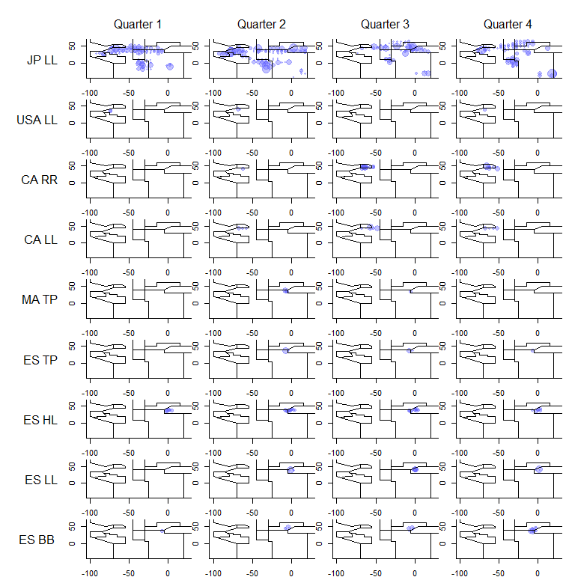

**Figure 2.** The seasonal-spatial coverage of the various fleets (Table 2) used in constructing the preliminary master index.

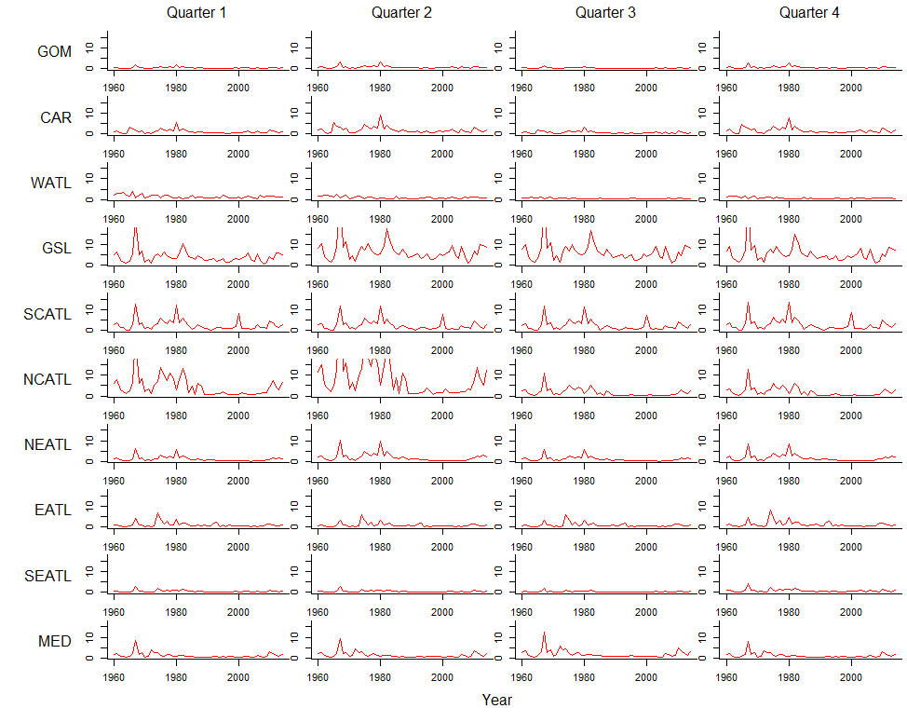

**Figure 3.** Spatial density predictions arising from the linear model (Eqn 1.)

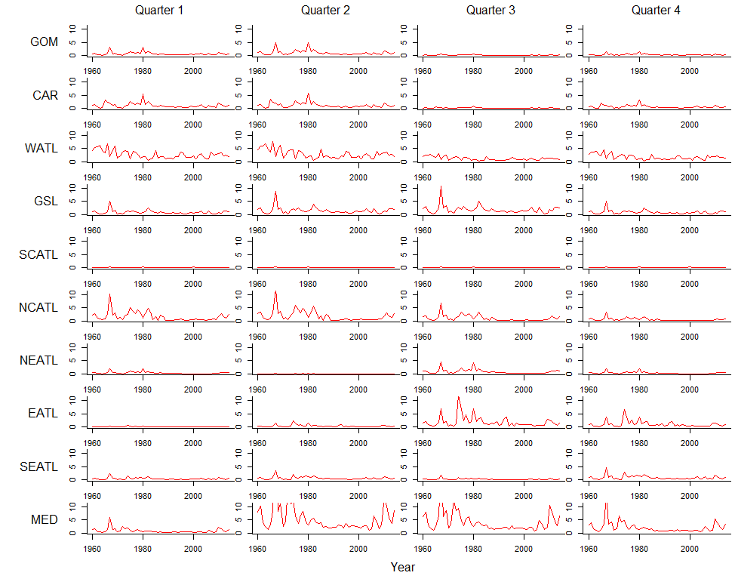

**Figure 4.** Unprocessed relative abundance predictions arising from linear model estimates of population density (Figure 3) multiplied by seasonal estimates of area size (Table 3).

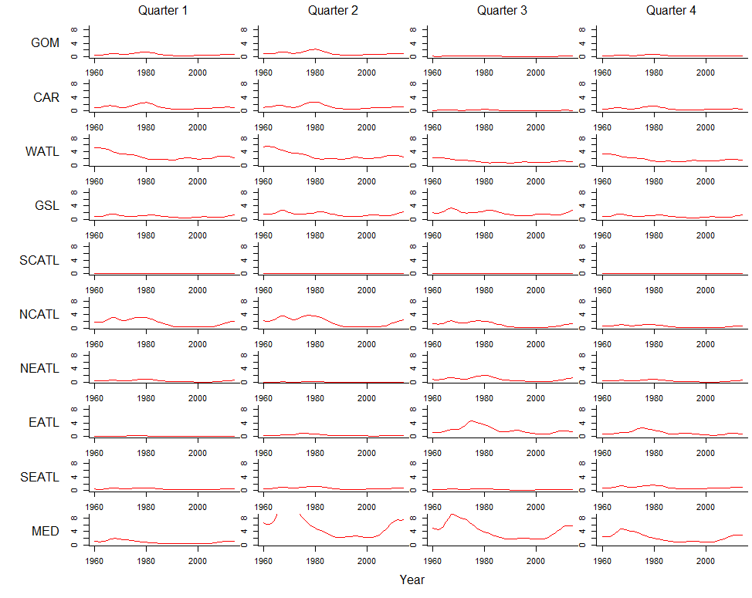

**Figure 5.** A preliminary master index by region and season that was calculated by temporally smoothing relative abundance estimates (Figure 4)(data smoothed by cubic spline).

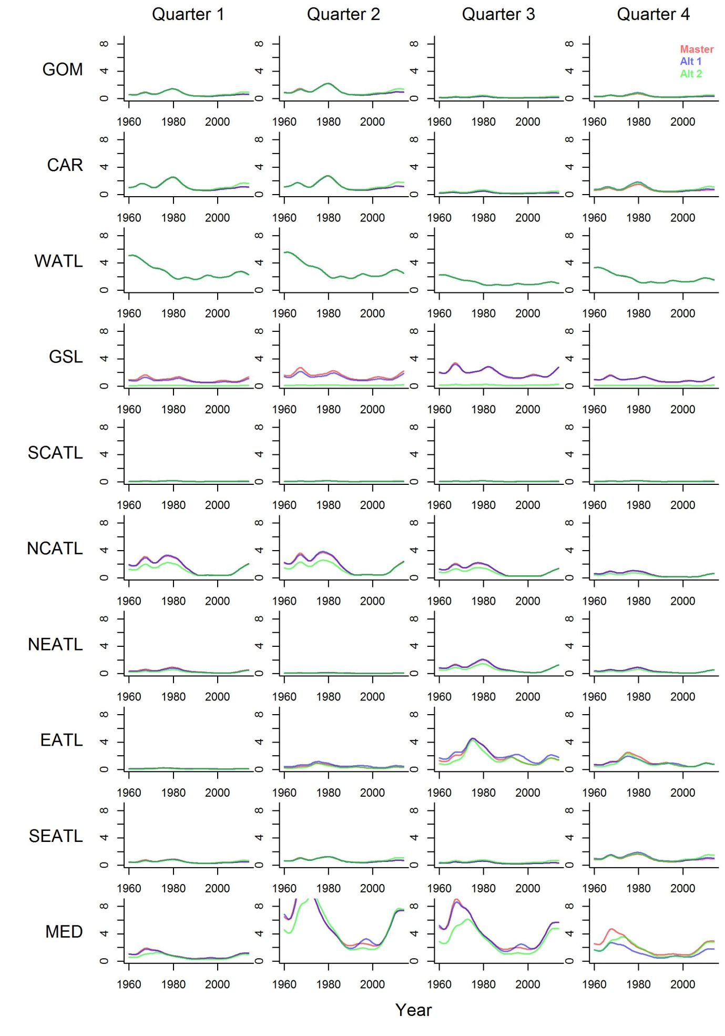

**Figure 6.** Comparison of the three derived indices: the master index (also Figure 5), alternative index 1 and alternative index 2. Alternative index 1 includes a greater number of fleets in the East, whereas alternative index 2 includes the same data as the master index but models fleet catchability without an area interaction.

1. IOF, 2202 Main Mall, University of British Columbia, Vancouver, B.C., Canada, V6T 1Z4. t.carruthers@oceans.ubc.ca